**ANSWERS TO FREQUENTLY ASKED QUESTIONS FOR STUDENTS (CLASSLINK/GOOGLE CLASSROOM/GOOGLE MEET)**

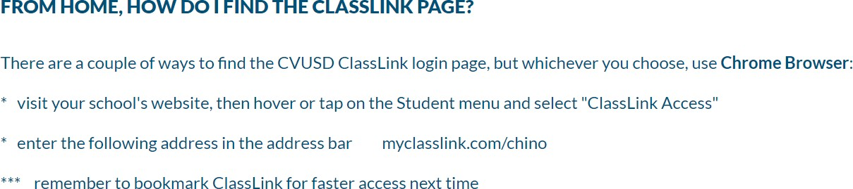

👉 HINT: IF YOU’RE USING A DISTRICT PROVIDED CHROMEBOOK, YOU WILL BE PROMPTED TO SIGN IN DIRECTLY TO CLASSLINK!

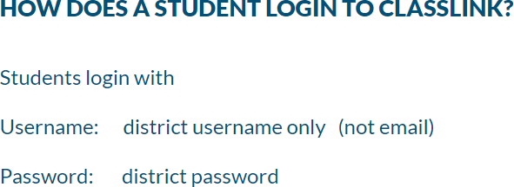

👉 HINT: THIS IS THE STANDARD FORMAT STUDENT PASSWORDS

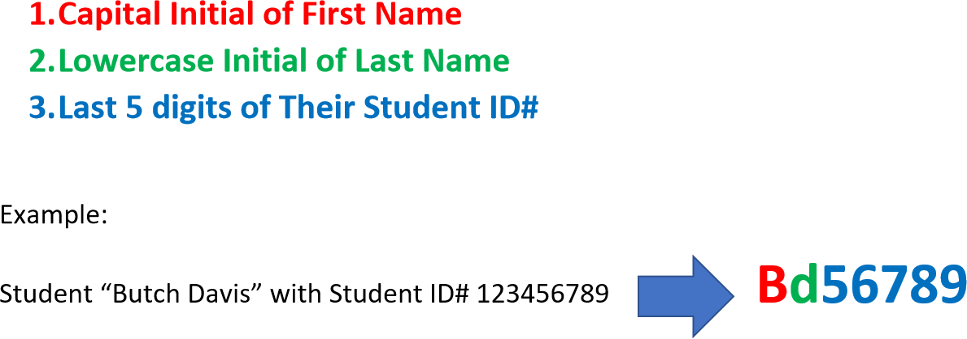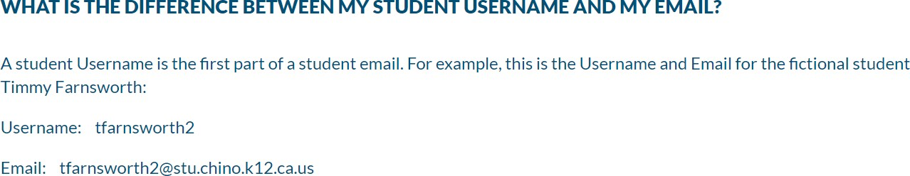

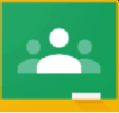Google Classroom

HELP! I CANNOT **JOIN MY TEACHER'S** GOOGLE **CLASSROOM?**

We understand how frustrating this must be. The problem is most likely a personal Google account on the device the student is using. To resolve this, the most sure-fire way is to REMOVE all personal Google Accounts from the device. The second alternative is to SIGN OUT of all personal accounts on the device. Finally, be sure to check that the student is in his DISTRICT Google Account every time he/she changes pages on the device.

MORE THAN **ONE GOOGLE ACCOUNT IS USED ON MY COMPUTER. HOW DO I KEEP** THEM

SEPARATE?

When students use computers at home, it is difficult to ensure Google accounts are not interrupting each other. The first defense for all users to constantly check which account is being used, as often as every page/screen change.

An effective way to prevent account interruption is to make the district account the default account by logging out of all Google accounts on the device, then logging into the district account first.

**I TYPED IN/TURNED IH I\DIY AHSWER/ASSIGNMENT, BUT MY TEACHER CANNOT SEE IT. WHAT DO I**

DO?

You have to click Turn in twice. After clicking the Turn in button at the top-right, another pop-up window will ask for confirmation and have you click Turn in again.

**WHERE DO I FIND MATERIALS MY TEACHER HAS PUT INTO OUR GOOGLE CLASSROOM?**

Log into ClassLink and click the Google Classroom app. Then, click the Classwork link at the top. From this screen, you will see Materials with an icon on the left that looks like page with a ribbon or bookmark in the upper left.

Your teacher may have organized your materials into sections. Scroll and look for that.



👉 HINT: HOW YOU TURN IN ASSIGNMENTS DEPENDS ON HOW THE ASSIGNMENT IS SET UP BY YOUR TEACHER.

If your teacher ATTACHED A COPY of a document for you to use:

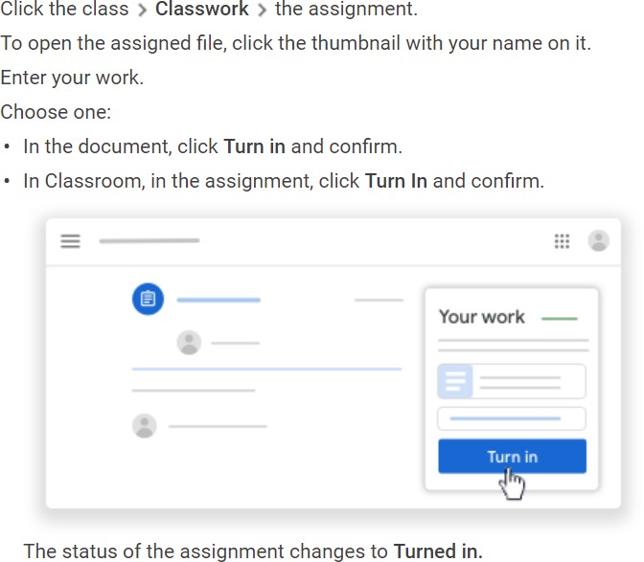

👉 HINT: AS YOU WORK, YOUR TEACHER CAN REVIEW YOUR PROGRESS BEFORE YOU TURN IN.

👉 HINT: WATCH THIS VIDEO TO SEE HOW!

<https://www.youtube.com/watch?v=85krkJyNCFQ&feature=youtu.be>

If you need to ATTACH YOUR OWN document, link, file, picture, video, etc.:

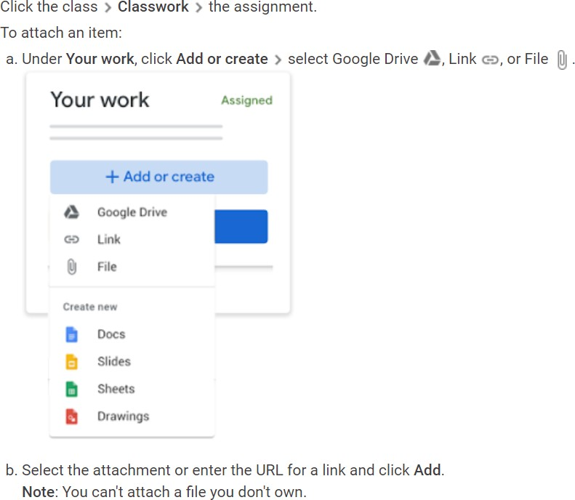

If you need to CREATE A NEW document:

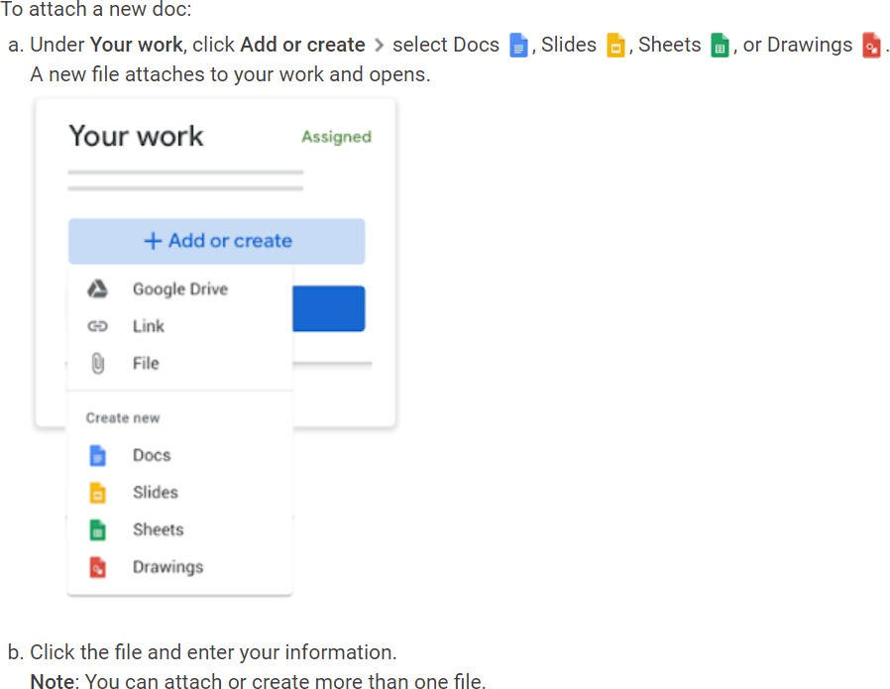

👉 HINT: WATCH THIS VIDEO TO SEE HOW!

<https://www.youtube.com/watch?v=6NZHKwM3kpk>

👉 HINT: IF YOU HAVE A SMARTPHONE AND ARE ABLE TO DOWNLOAD THE GOOGLE CLASSROOM APP, YOU CAN EASILY ATTACH FILES, VIDEOS, PICTURES, ETC. FROM YOUR PHONE! YOU CAN ALSO CHOOSE TO USE THE CAMERA TO UPLOAD DIRECTLY. JUST CLICK “ADD ATTACHMENT” TO ATTACH AN ITEM OR CHOOSE CAMERA.

*ASK YOUR PARENTS BEFORE DOWNLOADING ANY APP!

If your teacher ATTACHED A QUIZ (through Google Forms) for you to complete:

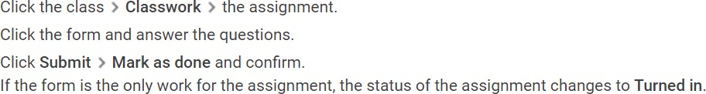



Kami is a Chrome extension that will allow you to write on documents or use a text box.

👉 HINT: WATCH THIS VIDEO TO SET UP AND USE KAMI FOR THE FIRST TIME!

<https://www.youtube.com/watch?v=w0XWM2yHWKI&feature=youtu.be>



Try copying the link to the video, signing out of your google account, opening a new tab and pasting the link. If this doesn’t work, try pasting the link into a different browser (like Edge, Safari, etc.).

If you can’t access the video, contact your teacher to let them know.



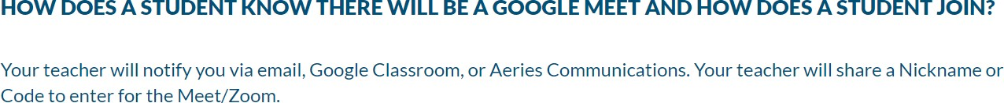

👉 HINT: IF YOUR TEACHER SENT YOU AN INVITE, YOU SHOULD SEE IT IN YOUR EMAIL AND IN YOUR GOOGLE CALENDAR. FROM EITHER PLACE, CLICK ON “JOIN HANGOUTS MEET” TO JOIN THE SPECIFIC MEET.

YOUR TEACHER MAY PROVIDE A LINK DIRECTLY TO THE GOOGLE MEET (OR HANGOUT) IN ANOTHER AREA, SUCH AS AERIES COMMUNICATION, THE STREAM IN YOUR GOOGLE CLASSROOM OR REMIND. IF SO, CLICK ON THE LINK TO JOIN THAT SPECIFIC MEET.